**Homework Wan Huzaifah bin Wan Azhar**

**Answer:**

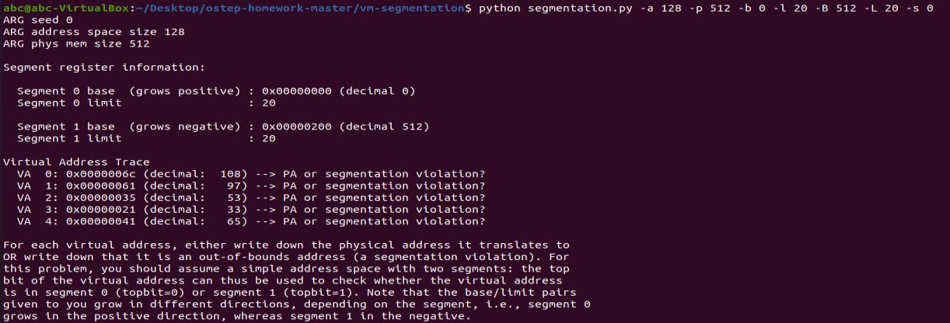

VA 0: -> Valid in Seg 1 (492)  
VA 1: -> Segmentation Violation (Seg 1)  
VA 2: -> Segmentation Violation (Seg 0)  
VA 3: -> Segmentation Violation (Seg 0)  
VA 4: -> Segmentation Violation (Seg 1)

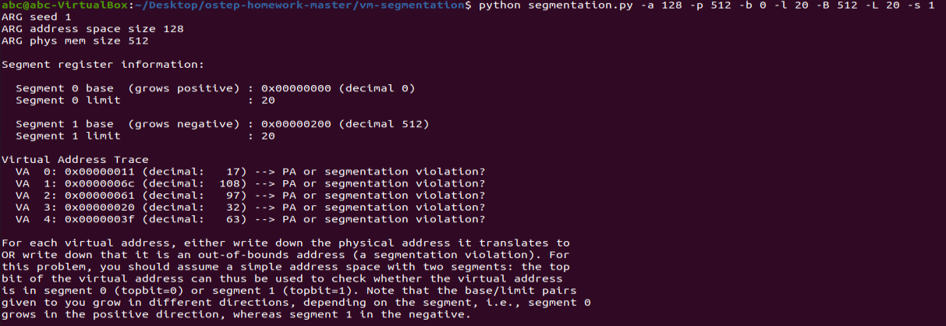

VA 0: -> Valid in Seg 0 (17)  
VA 1: -> Valid in Seg 1 (492)  
VA 2: -> Segmentation Violation (Seg 1)  
VA 3: -> Segmentation Violation (Seg 0)  
VA 4: -> Segmentation Violation (Seg 0)

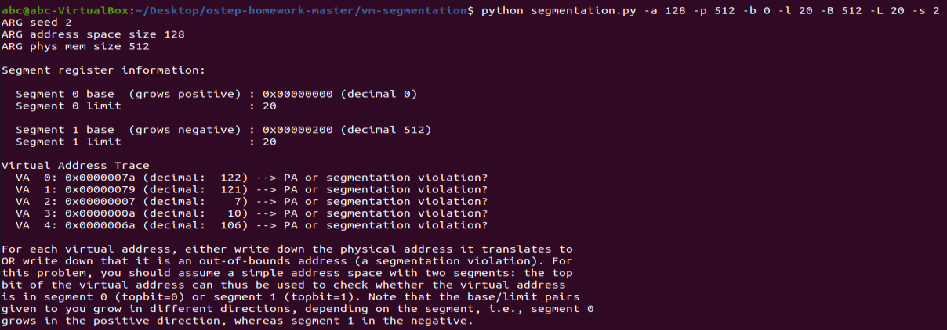

VA0: -> Valid in Seg 1 (506)  
VA1: -> Valid in Seg 1 (505)  
VA2: -> Valid in Seg 0 (7)  
VA3: -> Valid in Seg 0 (10)  
VA 4: -> Segmentation Violation (Seg 1)



* Highest legal virtual address in segment 0 is 19.
* Lowest legal virtual address in segment 1 is 108.
* Lowest and highest illegal address in this address space is 20 and 491.
* Run with “python segmentation.py -a 128 -p 512 -b 0 -l 20 -B 512 -L 20 -A 19,20,107,108,129 -c” to verify above answer.



* Run with parameter –b 0 –l0 2 –b1 16 –l1 2



* Increase the limit or bound of the segments so that it covers 90% of the physical address.
* Use the –l0 and –l1 parameter



* The easiest is to run the bound of both segment to be 0